Data Analytic with Tableau
ASSIGNMENT 3:
Aim: The growth of supermarkets in the most populated cities is increasing and market competitions are also high. The dataset is one of the historical sales of supermarket company which has recorded in 3 different branches for 3 months data.
Creating Dashboards:
Dashboard 1:
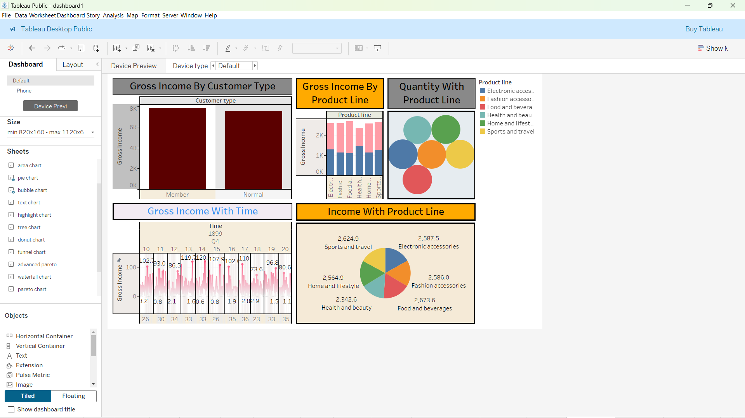

DASHBOARD 2:

